23MAT216 – Probability and Random Processes
In MATLAB, the Joint Probability Mass Function (JPMF) is used to represent the probability distribution of two discrete random variables. You can define a JPMF using a matrix and perform operations such as marginalization, conditional probabilities, expectations and standard deviations.
Defining a Joint PMF
To compute JPMF for two discrete random variables X and Y:
% Define the joint PMF matrix P(X, Y)
P = [0.1 0.15 0.05;
0.2 0.1 0.1;
0.05 0.15 0.1];

% Verify that it's a valid PMF (sum must be 1)
sum_P = sum(P, 'all');

% Display the matrix
disp('Joint PMF matrix:');
disp(P);
disp(['Sum of all probabilities: ', num2str(sum_P)]);

Computing Marginal PMFs
To compute the marginal probability distributions of X and Y:
% Marginal P(X) by summing across rows
P_X = sum(P, 2);

% Marginal P(Y) by summing across columns
P_Y = sum(P, 1);

% Display results
disp('Marginal P(X):');
disp(P_X);

disp('Marginal P(Y):');
disp(P_Y);

Computing Conditional Probabilities
To compute P(Y∣X), which is the probability of Y given X:
% Conditional P(Y | X) = P(X, Y) / P(X)
P_Y_given_X = P ./ P_X;

% Display results
disp('Conditional Probability P(Y | X):');
disp(P_Y_given_X);

Visualization
To visualize the joint PMF as a 3D bar plot:
[X_vals, Y_vals] = meshgrid(1:size(P,2), 1:size(P,1));
bar3(P);
xlabel('Y values');
ylabel ('X values');
zlabel ('P(X, Y)');
title ('Joint PMF Visualization');

MATLAB Commands for Joint Probability Mass Function (JPMF),Covariance,and Correlation

Joint Probability Mass Function (JPMF)

% Define possible values of X and Y
X = [0 1 2];
Y = [0 1];

% Define the Joint Probability Mass Function (JPMF)
P_XY = [0.2 0.1; % P(X=0, Y=0), P(X=0, Y=1)
0.3 0.1; % P(X=1, Y=0), P(X=1, Y=1)
0.2 0.1]; % P(X=2, Y=0), P(X=2, Y=1)

% Display the joint probability table
disp('Joint Probability Mass Function (JPMF):');
disp(P_XY);

% Marginal probabilities
P_X = sum(P_XY, 2); % Summing over columns for P(X)
P_Y = sum(P_XY, 1); % Summing over rows for P(Y)

disp('Marginal Probabilities P(X):');
disp(P_X);
disp('Marginal Probabilities P(Y):');
disp(P_Y);

Covariance Calculation (Covariance measures the relationship between two random variables)

% Define the values of X and Y
X_vals = [0 1 2];
Y_vals = [0 1];

% Compute E[X], E[Y]
E_X = sum(X_vals .* P_X');
E_Y = sum(Y_vals .* P_Y);

% Compute E[XY]
E_XY = sum(sum((X_vals' * Y_vals) .* P_XY));

% Compute Covariance
cov_XY = E_XY - (E_X * E_Y);
disp(['Covariance: ', num2str(cov_XY)]);

Correlation Calculation (Correlation normalizes the covariance by the standard deviations of X and Y)

% Compute E[X^2] and E[Y^2]
E_X2 = sum((X_vals.^2) .* P_X');
E_Y2 = sum((Y_vals.^2) .* P_Y);

% Compute Variances
Var_X = E_X2 - E_X^2;
Var_Y = E_Y2 - E_Y^2;

% Compute Standard Deviations
std_X = sqrt(Var_X);
std_Y = sqrt(Var_Y);

% Compute Correlation Coefficient
corr_XY = cov_XY / (std_X * std_Y);
disp(['Correlation Coefficient: ', num2str(corr_XY)]);

Computing JPMF for Independent Discrete Random Variables

% Define discrete values for X and Y
X = [1 2 3]; % Possible values of X
Y = [1 2 3]; % Possible values of Y

% Define the PMFs for X and Y (must sum to 1)
PX = [0.3 0.5 0.2]; % P(X = x)
PY = [0.4 0.4 0.2]; % P(Y = y)

% Compute the JPMF using the outer product
JPMF = PX' * PY; % Outer product gives the joint probability table

% Display the joint PMF table
disp('Joint Probability Mass Function (JPMF):');
disp(JPMF);

MATLAB Code for 3D Visualization of JPMF

% Define discrete values for X and Y
X = [1 2 3]; % Possible values of X
Y = [1 2 3]; % Possible values of Y

% Define the PMFs for X and Y (must sum to 1)
PX = [0.3 0.5 0.2]; % P(X = x)
PY = [0.4 0.4 0.2]; % P(Y = y)

% Compute the JPMF using the outer product
JPMF = PX' * PY; % Outer product gives the joint probability table

% Create a meshgrid for X and Y values
[X_grid, Y_grid] = meshgrid(X, Y);

% Convert to column vectors for plotting
X_data = X_grid(:);
Y_data = Y_grid(:);
JPMF_data = JPMF(:);

% Plot the 3D bar graph
figure;
bar3(JPMF);
xlabel('Y values');
ylabel('X values');
zlabel('P(X, Y)');
title('Joint Probability Mass Function (JPMF)');
colorbar; % Adds color scale
grid on;

% Adjust tick labels to match X and Y values
ax = gca;
ax.XTickLabel = Y;
ax.YTickLabel = X;

Example

% Define the Joint PMF (Example)
JPMF = [0.1 0.2 0.1;
0.2 0.1 0.3]; % Rows -> X values, Columns -> Y values

% Ensure JPMF is valid (Sum must be 1)
assert(abs(sum(JPMF(:)) - 1) < 1e-6, 'Error: JPMF does not sum to 1');

% 1. Marginal Probability of X
P_X = sum(JPMF, 2); % Sum over columns

% 2. Marginal Probability of Y
P_Y = sum(JPMF, 1); % Sum over rows

% 3. Find a specific joint probability P(X=1, Y=2)
x_index = 1; % X = first row
y_index = 2; % Y = second column
P_joint = JPMF(x_index, y_index);

% 4. Compute Conditional Probability P(Y | X)
P_Y_given_X = JPMF ./ P_X; % Element-wise division

% 5. Compute P(X) * P(Y) (for independence check)
P_independent = P_X * P_Y; % Outer product

% 6. Check if X and Y are independent (P(X,Y) = P(X)P(Y))
independent = all(all(abs(JPMF - P_independent) < 1e-6));

% Display Results
disp('Joint PMF:');
disp(JPMF);

disp('Marginal Probability P(X):');
disp(P_X);

disp('Marginal Probability P(Y):');
disp(P_Y);

disp(['P(X=1, Y=2) = ', num2str(P_joint)]);

disp('Conditional Probability P(Y | X):');
disp(P_Y_given_X);

if independent
disp('X and Y are independent.');
else
disp('X and Y are NOT independent.');
end

MATLAB script to compute the required joint probabilities based on the given joint probability mass function (PMF):

% Define discrete values for X and Y
X = [0 1 2]; % Possible values of X
Y = [0 1 2]; % Possible values of Y

% Define the joint probability mass function (PMF)
P = [0.06, 0.08, 0.11;
0.08, 0.11, 0.14;
0.11, 0.14, 0.17];

% Compute marginal distributions
Px = sum(P, 2); % Sum over columns for P(X)
Py = sum(P, 1); % Sum over rows for P(Y)

% Compute conditional distribution P(X | Y=0)
Py_0 = Py(1); % P(Y=0)
Px_given_Y0 = P(:,1) / Py_0;

% Compute individual joint probabilities
P_00 = P(1,1);
P_11 = P(2,2);
P_22 = P(3,3);

% Compute P(X <= 1, Y <= 1)
P_xle1_yle1 = sum(sum(P(1:2,1:2)));

% Compute P(X <= 1, Y <= 2)
P_xle1_yle2 = sum(sum(P(1:2,1:3)));

% Compute P(X <= 2, Y <= 1)
P_xle2_yle1 = sum(sum(P(1:3,1:2)));

% Compute P(X <= 2, Y <= 2)
P_xle2_yle2 = sum(sum(P(1:3,1:3)));

% Display results
disp('Marginal distribution P(X):');
disp(Px);
disp('Marginal distribution P(Y):');
disp(Py);
disp('Conditional distribution P(X | Y=0):');
disp(Px_given_Y0);
disp('Joint probabilities:');
disp(['P(X=0, Y=0): ', num2str(P_00)]);
disp(['P(X=1, Y=1): ', num2str(P_11)]);
disp(['P(X=2, Y=2): ', num2str(P_22)]);
disp(['P(X<=1, Y<=1): ', num2str(P_xle1_yle1)]);
disp(['P(X<=1, Y<=2): ', num2str(P_xle1_yle2)]);
disp(['P(X<=2, Y<=1): ', num2str(P_xle2_yle1)]);
disp(['P(X<=2, Y<=2): ', num2str(P_xle2_yle2)]);

Here is the MATLAB code to compute the required probability distributions, expectations, variances, covariance, correlation, independence check, conditional distribution, conditional mean, and probability calculations.
This MATLAB code calculates all required statistical measures and probability distributions based on the given joint PMF. Let me know if you need any modifications or explanations!

Given the joint probability mass function (JPMF) for two discrete random variables:
$$P(X=x, Y=y)=\frac{x+y}{36}, x=1, 2, 3; y=1, 2, 3$$
Find the following:
- Marginal probability distribution of X and Y.
- Expectation of X, Y, X+Y and XY.
- Variance of X and Y.
- Covariance of X and Y.
- Correlation between X and Y.
- Are X and Y independent random variables?
- Conditional distribution of Y given X = 1.
- Conditional mean of Y given X = 1.
$P(X≤2)$ $P(X≤1, Y≤3)$ $P(X≥1, Y≥2)$.

clc;
clear;

% Define the joint probability mass function P(X=x, Y=y) = (x+y)/36
x_vals = 1:3;
y_vals = 1:3;
[X, Y] = meshgrid(x_vals, y_vals);
P = (X + Y) / 36;

% 1. Marginal probability distributions of X and Y
P_X = sum(P, 1); % Marginal of X
P_Y = sum(P, 2)'; % Marginal of Y

disp('Marginal probability distribution of X:');
disp(P_X);
disp('Marginal probability distribution of Y:');
disp(P_Y);

% 2. Expectations of X, Y, X+Y, and XY
E_X = sum(P_X .* x_vals);
E_Y = sum(P_Y .* y_vals);
E_XplusY = sum(sum(P .* (X + Y)));
E_XY = sum(sum(P .* (X .* Y)));

disp('Expectation of X:');
disp(E_X);
disp('Expectation of Y:');
disp(E_Y);
disp('Expectation of X+Y:');
disp(E_XplusY);
disp('Expectation of XY:');
disp(E_XY);

% 3. Variance of X and Y
E_X2 = sum(P_X .* (x_vals.^2));
E_Y2 = sum(P_Y .* (y_vals.^2));

Var_X = E_X2 - E_X^2;
Var_Y = E_Y2 - E_Y^2;

disp('Variance of X:');
disp(Var_X);
disp('Variance of Y:');
disp(Var_Y);

% 4. Covariance of X and Y
Cov_XY = E_XY - E_X * E_Y;

disp('Covariance of X and Y:');
disp(Cov_XY);

% 5. Correlation between X and Y
Corr_XY = Cov_XY / (sqrt(Var_X) * sqrt(Var_Y));

disp('Correlation between X and Y:');
disp(Corr_XY);

% 6. Are X and Y independent?
are_independent = all(all(P == P_X' * P_Y));

disp('Are X and Y independent?');
disp(are_independent);

% 7. Conditional distribution of Y given X = 1
P_Y_given_X1 = P(:, 1) / P_X(1);

disp('Conditional distribution of Y given X = 1:');
disp(P_Y_given_X1');

% 8. Conditional mean of Y given X = 1
E_Y_given_X1 = sum(y_vals .* P_Y_given_X1');
disp('Conditional mean of Y given X = 1:');
disp(E_Y_given_X1);

% 9. Probability calculations P_X_le_2 = sum(P_X(1:2));
P_X_le_1_Y_le_3 = sum(P(1, :));
P_X_ge_1_Y_ge_2 = sum(sum(P(2:3, 1:3))) + sum(P(1, 2:3));
disp('P(X <= 2):');
disp(P_X_le_2);
disp('P(X <= 1, Y <= 3):');
disp(P_X_le_1_Y_le_3);
disp('P(X >= 1, Y >= 2):');
disp(P_X_ge_1_Y_ge_2);

Here’s a MATLAB script that computes the regression lines for two-dimensional random variables using the given statistical measures derived from a joint probability mass function (jpmf) or joint probability density function (jpdf).

Formulas for Regression Lines
The regression lines of Y on X and X on Y are given by:

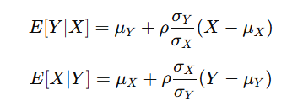
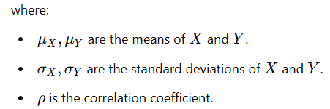
% MATLAB script to compute regression lines for two-dimensional random variables

clc; clear; close all;

% Define the joint probability mass function (jpmf) or joint probability density function (jpdf)
% Example: Joint PMF for discrete random variables
X = [1, 2, 3]; % Possible values of X
Y = [1, 2, 3]; % Possible values of Y
jpmf = [0.1, 0.2, 0.1;
0.2, 0.1, 0.1;
0.1, 0.1, 0.1]; % Joint probability mass function

% Compute marginal distributions
px = sum(jpmf, 2); % P(X)
py = sum(jpmf, 1); % P(Y)

% Compute means
mu_X = sum(X .* px');
mu_Y = sum(Y .* py);

% Compute standard deviations
sigma_X = sqrt(sum(((X - mu_X).^2) .* px'));
sigma_Y = sqrt(sum(((Y - mu_Y).^2) .* py));

% Compute covariance
E_XY = sum(sum((X' * Y) .* jpmf)); % E[XY]
cov_XY = E_XY - mu_X * mu_Y;

% Compute correlation coefficient
rho = cov_XY / (sigma_X * sigma_Y);

% Regression lines
% E[Y | X] = mu_Y + rho * (sigma_Y / sigma_X) * (X - mu_X)
EY_X = mu_Y + rho * (sigma_Y / sigma_X) * (X - mu_X);

% E[X | Y] = mu_X + rho * (sigma_X / sigma_Y) * (Y - mu_Y)
EX_Y = mu_X + rho * (sigma_X / sigma_Y) * (Y - mu_Y);

% Display results
fprintf('Mean of X: %.4f\n', mu_X);
fprintf('Mean of Y: %.4f\n', mu_Y);
fprintf('Standard deviation of X: %.4f\n', sigma_X);
fprintf('Standard deviation of Y: %.4f\n', sigma_Y);
fprintf('Correlation coefficient (rho): %.4f\n', rho);

% Plot regression lines
figure;
scatter(X, EY_X, 'ro', 'filled'); hold on;
plot(X, EY_X, 'r-', 'LineWidth', 2);
scatter(EX_Y, Y, 'bo', 'filled');
plot(EX_Y, Y, 'b-', 'LineWidth', 2);
legend('E[Y|X]', 'Regression Line Y on X', 'E[X|Y]', 'Regression Line X on Y');
xlabel('X and Y values');
ylabel('Conditional Expectations');
title('Regression Lines');
grid on;

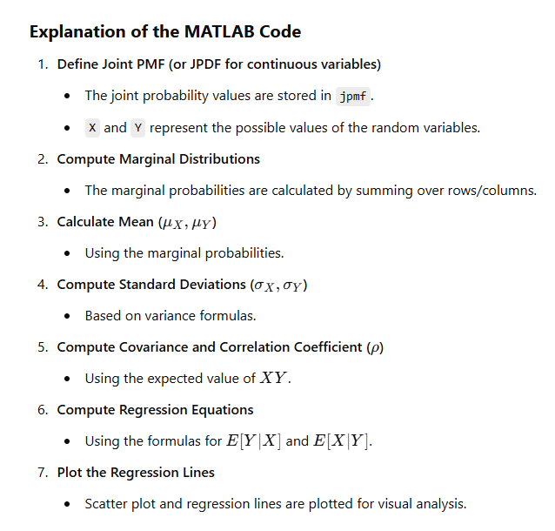
Practice Problems

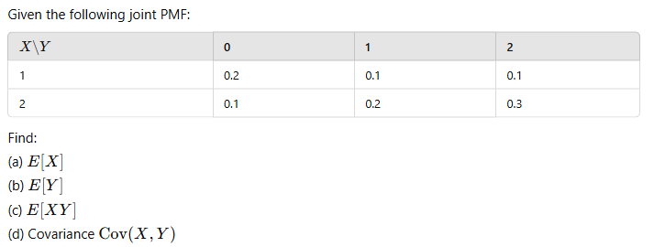
- Suppose the joint probability mass function of a bivariate random variable (X,Y) is given by: p(x,y) = 1/3 for (0,1) , (1,0) , (2,0) ; 0 , otherwise. Are X and Y independent?
- Given is the joint probabilities of X and Y.

Y  X | 0 | 1 | 2
0 | 0.02 | 0.08 | 0.10
1 | 0.05 | 0.20 | 0.25
2 | 0.03 | 0.12 | 0.15
  - Obtain the marginal distributions.
  - Obtain the conditional distributions of X given Y = 0.
  - Obtain the conditional distributions of Y given X = 0.
  - P(X=0, Y=0), P(X=1, Y=1), P(X=2, Y=2), P(X<=1, Y<=1), P(X<=1, Y<=2), P(X<=2, Y<=1), P(X<=2, Y<=2)

- The joint probability mass function pmf of X and Y is
Y  X | 0 | 1 | 2
0 | 0.1 | 0.04 | 0.02
1 | 0.08 | 0.20 | 0.06
2 | 0.06 | 0.14 | 0.30
Compute the marginal pmf of Y, P[ X ≤ 1,Y ≤ 1] and check if X and Y are independent.

- In an automobile plant two tasks are performed by robots. The first entails welding two joints; the second, tightening three bolts. Let X denote the number of defective welds and Y the number of improperly tightened bolts produced per car. Since X and Y are each, discrete, (X, Y) is a two-dimensional discrete random variable. Past data indicates that the joint density for (X, Y) is as shown in the Table.

Y  X | 0 | 1 | 2 | 3
0 | 0.840 | 0.030 | 0.020 | 0.010
1 | 0.060 | 0.010 | 0.008 | 0.002
2 | 0.010 | 0.005 | 0.004 | 0.001

Find the following:
- Marginal probability distributions of X and Y.
- Expectations of X, Y, X+Y and XY.
- Variances of X and Y.
- Covariance of X and Y.
- Correlation between X and Y.
- Are X and Y independent random variables?
- Conditional distribution of Y given X.
- Probability that there will be no errors made by the robots.
- Probability that there will be exactly one error made by the robots.
- Probability that exactly two defective welds and one improperly tightened bolt will be produced by the robots.
- Probability that at least one defective weld and at least one improperly tightened bolt will be produced by the robots.
- Probability that at most one defective weld will be produced by the robots.
- Probability that at least two improperly tightened bolt will be produced by the robots.

- The two common types of errors made by programmers are syntax errors and errors in logic. For a simple language such as BASIC the number of such errors is usually small. Let X denote the number of syntax errors and Y the number of errors in logic made on the first run of a BASIC program. Assume that the joint density for (X, Y) is as shown in the Table.

Y  X | 0 | 1 | 2 | 3
0 | 0.400 | 0.100 | 0.020 | 0.005
1 | 0.300 | 0.040 | 0.010 | 0.004
2 | 0.040 | 0.010 | 0.009 | 0.003
3 | 0.009 | 0.008 | 0.007 | 0.003
4 | 0.008 | 0.007 | 0.005 | 0.002
5 | 0.005 | 0.002 | 0.002 | 0.001

Find the following:
- Marginal probability distributions of X and Y.
- Expectations of X, Y, X+Y and XY.
- Variances of X and Y.
- Covariance of X and Y.
- Correlation between X and Y.
- Are X and Y independent random variables?
- Conditional distribution of Y given X.
- Probability that a randomly selected program will have neither of these types of errors.
- Probability that a randomly selected program will contain at least one syntax error and at most one error in logic.
- Probability that a randomly selected program contains at least two syntax errors.
- Probability that a randomly selected program contains one or two errors in logic.

